GIT Workflow:
a recipe or recommendation for how to use Git to do a project in a more efficient and consistent way. Git workflow helps developers and DevOps team to leverage Git effectively and consistly. Due to focus on flexibility in managing changes, there is no standard process how to interact with Git. But when you are a member of team working on a git-managed project it is so important that all of you reach an agreement on how to apply the flow of changes. So, to be ensure that all of you are on the same page your team should agrree on a public workflow or the one developed by your own team.
Some of common workflows are:
centerelized workflow
feature branch workflow
gitflow workflow
forking workflow

Git flow:
It is used when more than one developer are collaborating on same team.

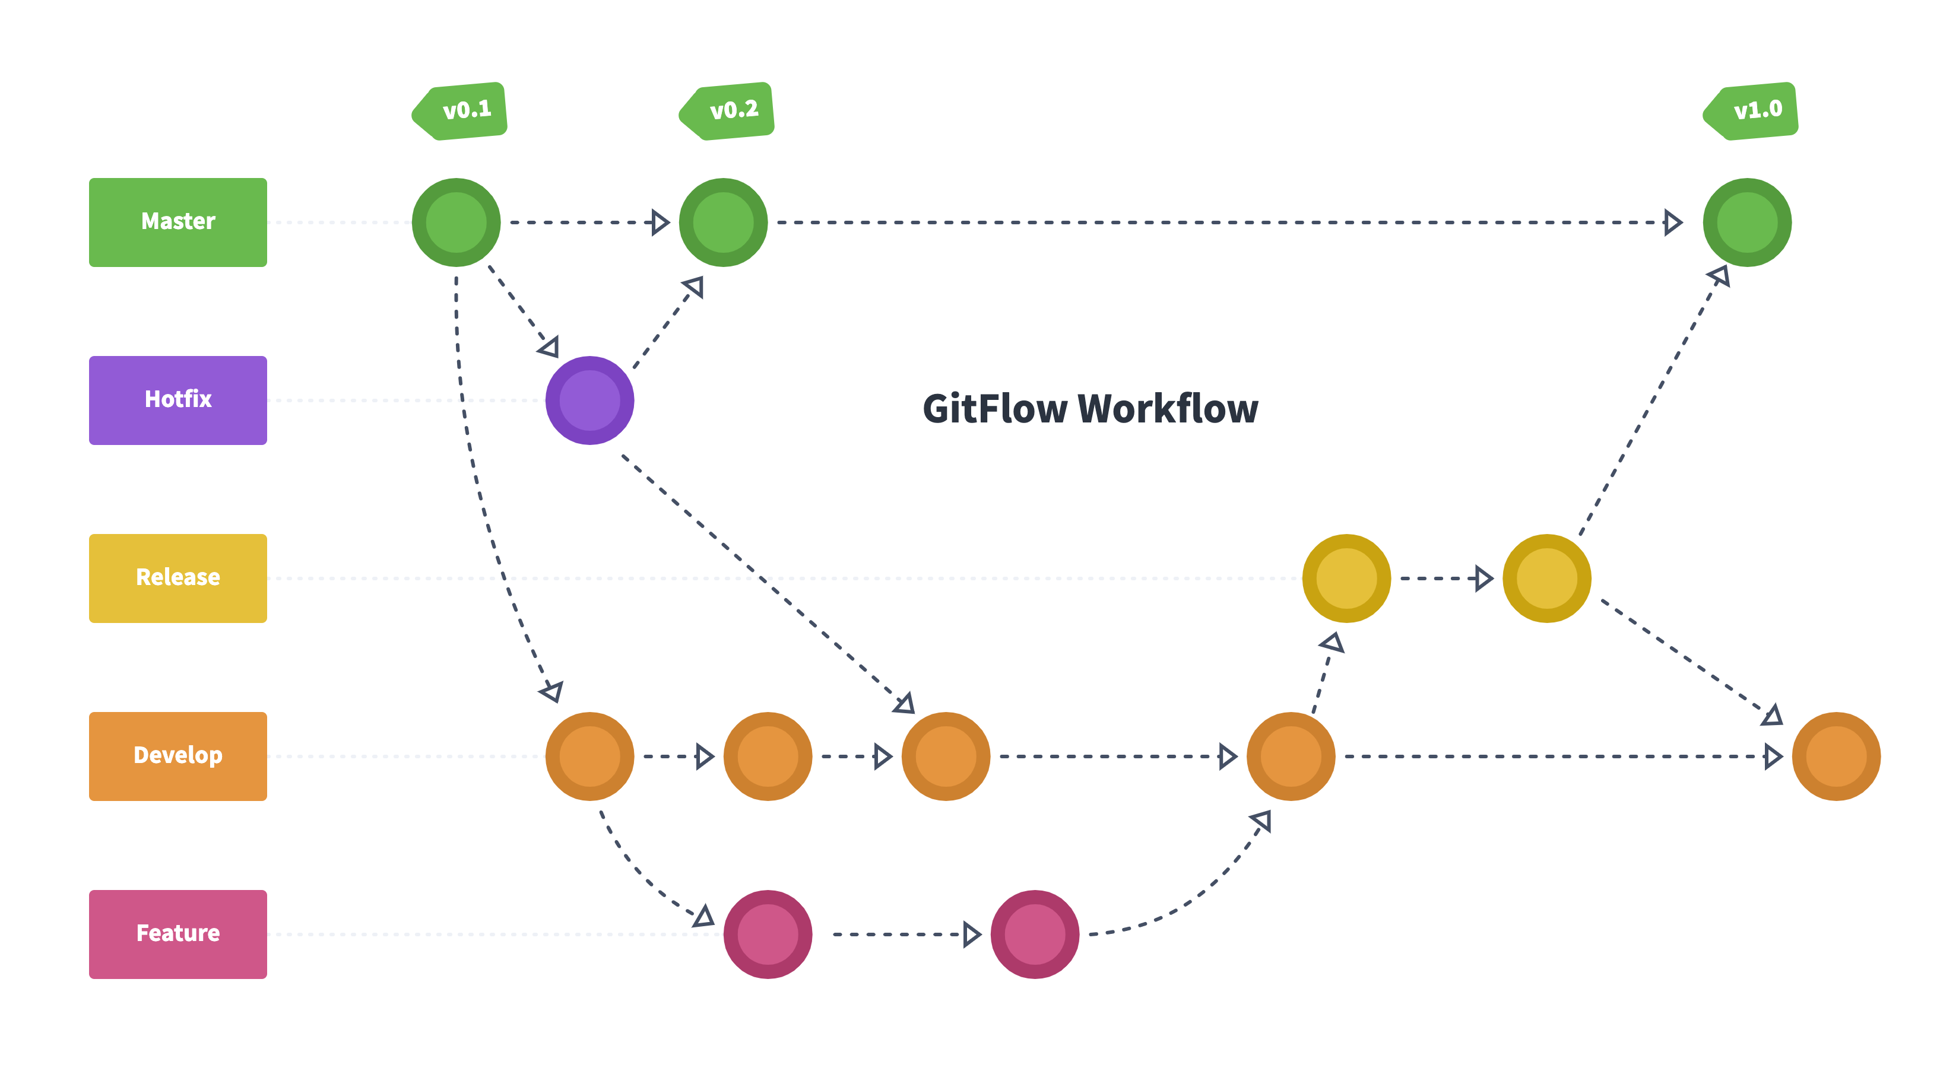
Main branches in git flow are:
Master:
representation of the ready to use state of a software
Develops:
representation of lastest development changes
Feature branches:
when it is goning to add a new feature (functionality) to the programm, developers branch off the develop branch, which the feature branch. Once, the feature implemntation is done the developer send a pull request to develop branch. After reviewing and approving the feature, the changes will be merged back to the develop branch.
Release branches:
A branch which is brached off develop branch and after some work will be mergeed back to develop and master branch.
Some pre-released bug-fixes are done in this branches and after each bug-fix the realse branch is merged back to develop branch.
Its name is a number reflecting new version number.
Hotfix branch:
when there is something wrong with the released version of the programme. A branch is branched off master and after fixing bug the hotfix branch is merged back to master and develop branches.

